2016 hint

2016 HINT
On January 5th, 2016, Cicada’s official Twitter account tweeted a link to infotomb.com/4gq25.jpg . This link no longer works, as Infotomb is now non-functional. This link led to the following image:
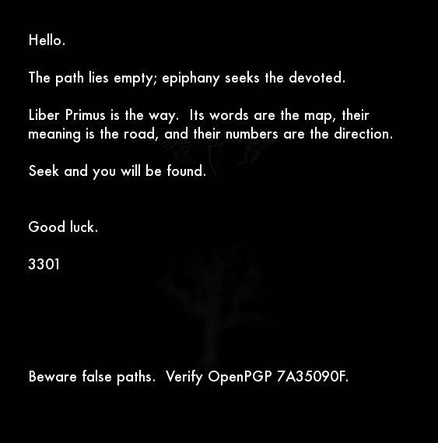4gq25.jpg
The apparent purpose of this image, 4gq25.jpg , seems to be to confirm the status of Liber Primus as Cicada’s active challenge — as well as to warn against pursuing the puzzles of imitators.
Notes:
+ Two figures can be seen faintly in the background of 4gq25.jpg : a cicada and an oak tree — both also found in Liber Primus.
————
* Given 4gq25.jpg‘s use of the phrase ‘epiphany seeks the devoted’, as well as prior years’ puzzles’ release dates and 4gq25.jpg‘s release date of January 5th, it should be noted that January 6th is the traditional date of the Christian holiday ‘Epiphany‘. This observation has not led to any progress, however.
** Cicada’s three annual challenges (2012, 2013, 2014) were released, respectively, on:
January 4th, January 5th, and January 6th.
*** The word ‘Epiphany‘ has been used before. In zN4h51m.jpg, the opening image of the 2014 round released on January 6th, 2014, the phrase ‘Epiphany is upon you.‘ was used.

